**Training and Attestation**

**Purpose**

The purpose of this document is to identify the training objectives completed, specific tasks completed, and attest that I completed the exercises utilizing my own understanding of the material.

**Exercise 2.9.2**

**Core**

1. Identify physical characteristics of internetworking devices.
   1. In physical mode, locate console ports on EAST router.
   2. Identify interfaces on EAST router.
   3. Identify module expansion slots for EAST router.
2. Select correct modules for connectivity.
   1. Add module to the EAST router for the purpose of allowing additional endpoint connections.
3. Connect devices.
   1. User proper cabling to connect all the devices.
4. Check connectivity.
5. Configure TabletPC interface Wireless0.
   1. Change Wireless0 port status to On.
   2. Change 3G/4G Cell1 interface to On.
   3. Verify changes allow access cisco.pka website.

**Screenshots of Completion**

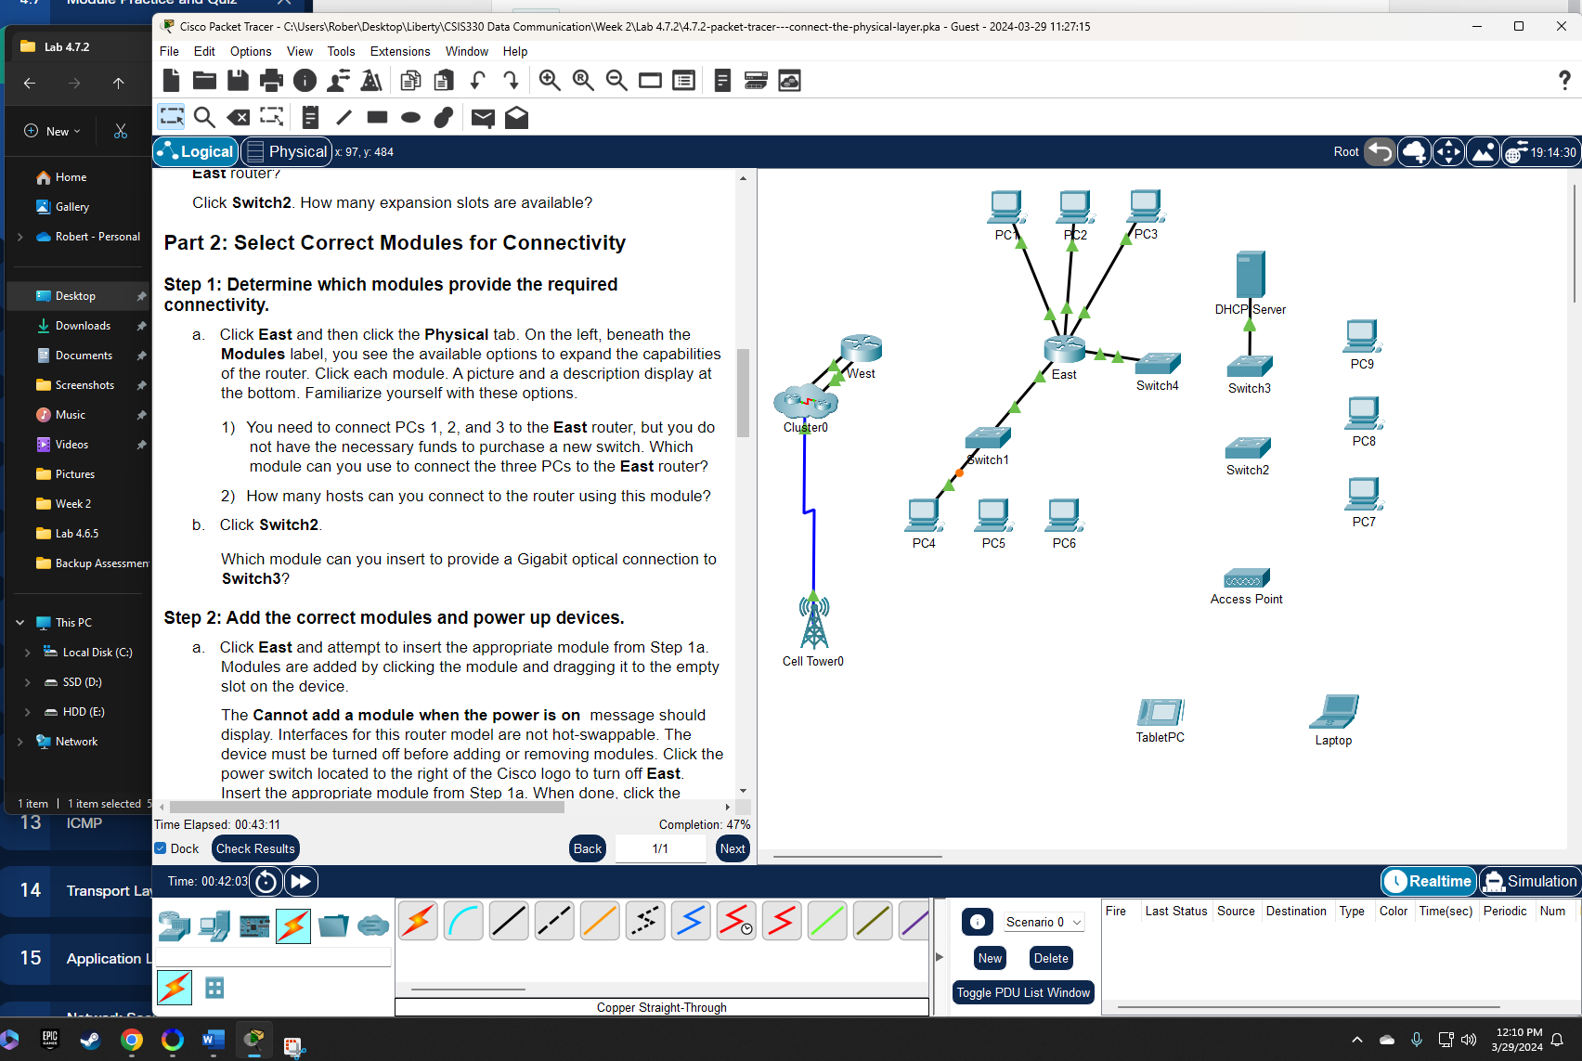

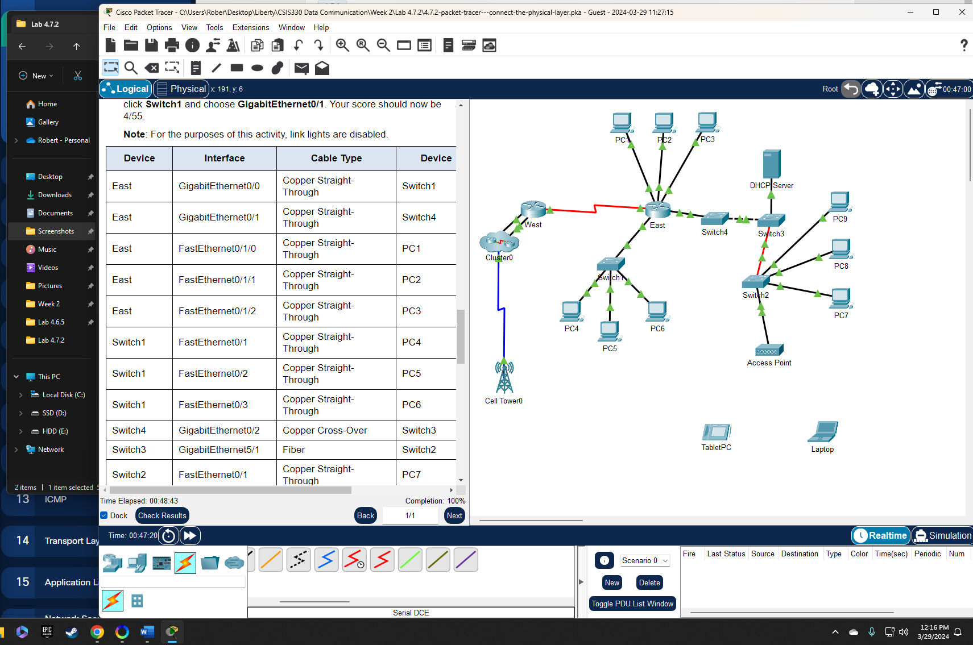

**Attestation**

I certify that I completed all the work required for this lab using the skills and knowledge gained from completing the Liberty University course work and Official Cisco CCNA training material. The answers were my own and I did not plagiarize anyone else’s work.

